UNIT TESTING:

As according to project requirements, I have two components in my project named "Home" and "Details".

According to expectation Home page will show "Hello world" on it, and secondly it will have a button that will be connected to another webpage that may be blank.

As we are going to do unit testing for this code so we will try in individually.

Test Case #1

First, we try code of Home component is that code will show the “Hello World” or not

Output is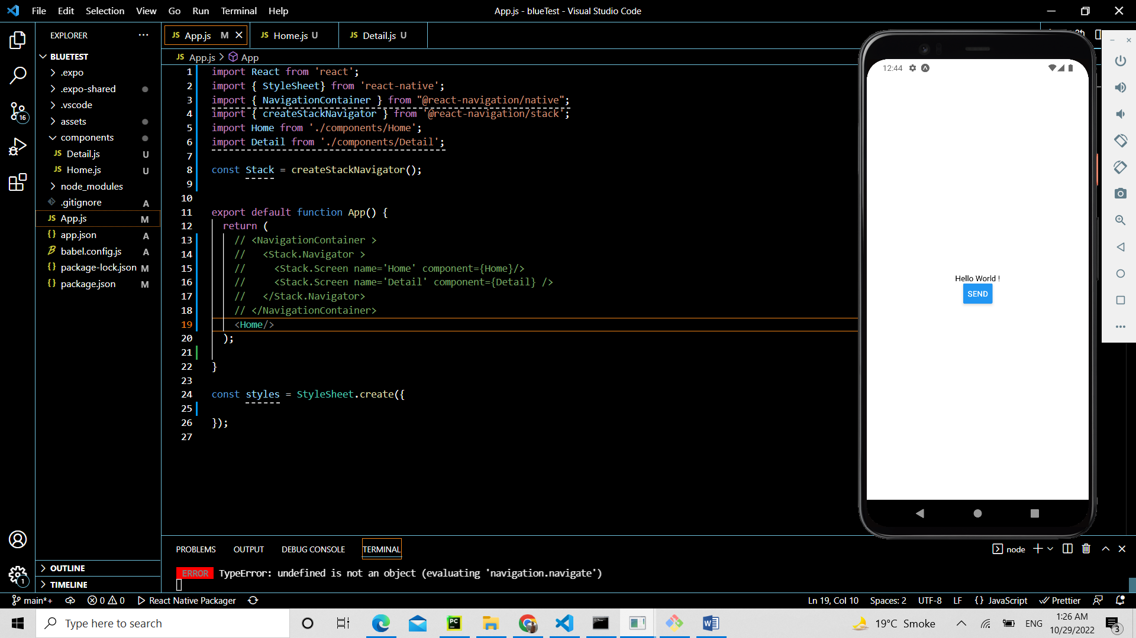

Second, we try code of Details component to confirm whether by pressing send button is there a link between these two pages or not

output is